IMAD: ASSIGNMENT 2

Description
Native Android App using Kotlin within Android Studio to help users study and verify hacks with questions. The app displays questions, loops through each hack whether True/False or Hacks and Urban Myths. The layout is built using XML and follows a clean, design to enhance user experience and readability.
Application built using Kotlin in Android Studio which helps the user’s study and maintain focus with interactive buttons and use of the Toast features within Kotlin

Referencing
(R. Netshidzivhani, pers. comm., 04 May 2026)
Netshidzivhani, R., 2026. Android UI Layouts. [PDF] The IIE. Available at: (provided by lecturer) [Accessed 31 March 2026].
GeeksforGeeks, n.d. LinearLayout and its Important Attributes with Examples in Android. [PDF] Available at: (provided as course material) [Accessed 31 March 2026].
GeeksforGeeks, n.d. RadioButton in Kotlin. [PDF] Available at: (provided as course material) [Accessed 31 March 2026].

Authors
Olerato Kgonothi - ST10520342
Kungawo Sotyato- ST10523740
Kelebogile Dubazana - ST10530421
Moshohli Tlhabane – ST10527278

ActivtiyMain.xml
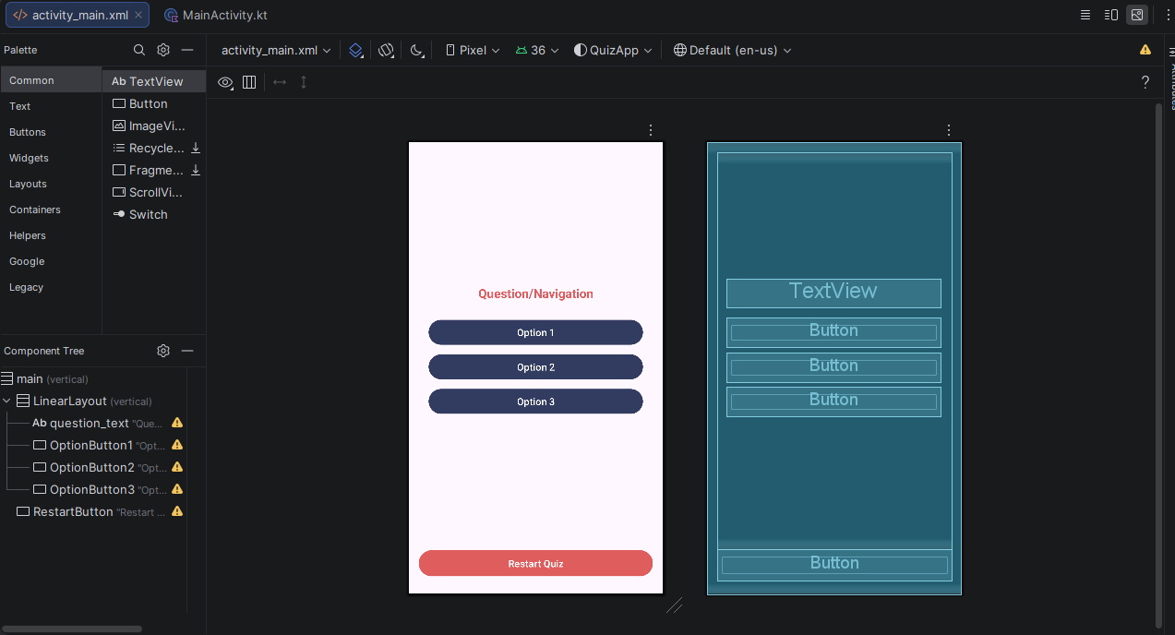
Figure 1 Design/Layout

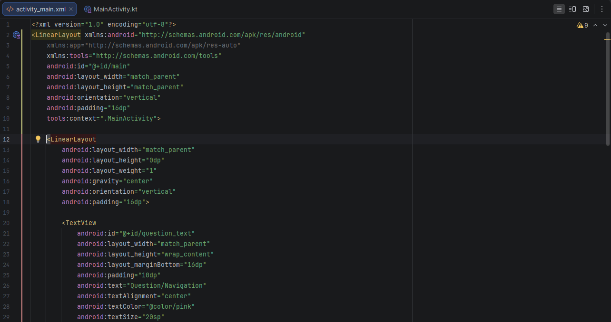
Figure 2 LinearLayout

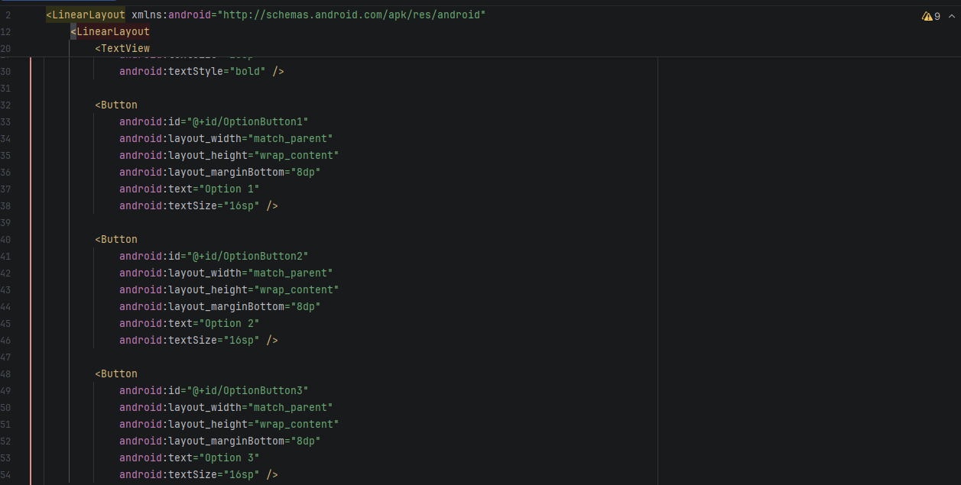
Figure 3 TextView

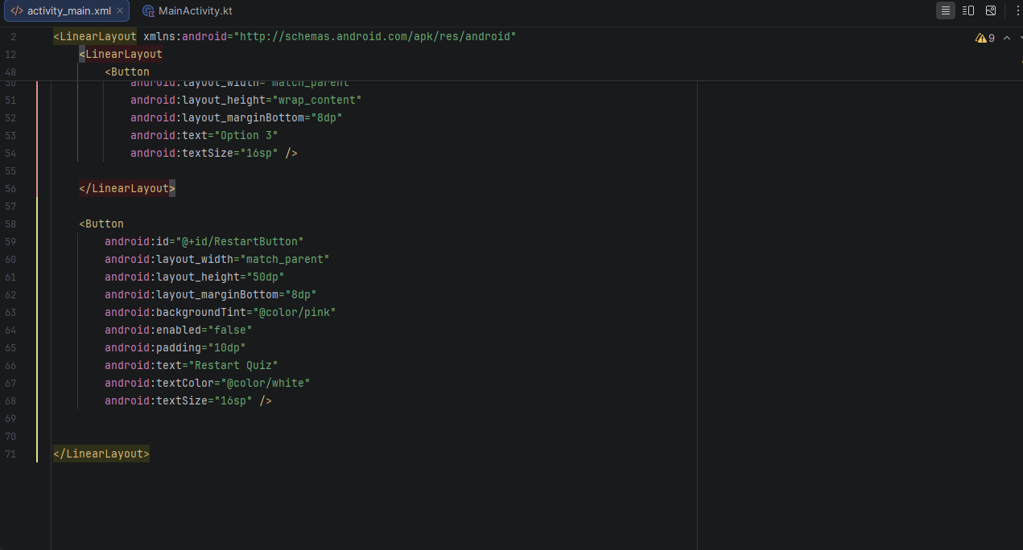
Figure 4 Button

MainActivity.kt
